THEORY QUESTIONS
This paper is in two sections: A and B. Answer Question 1 in Section A and any other three questions in Section B.
Answer all the questions in your answer booklet.
Credit will be given for clarity of expression and orderly presentation of material.

SECTION A
Answer all questions in this section
1.
(a)

Fig. 1(a) is an illustration of the longitudinal section of the mammalian heart.
Study it carefully and answer the questions that follow
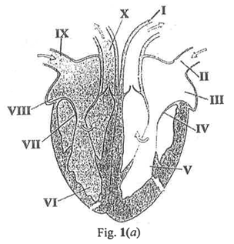
(i)

State one function for each of the parts labelled I, II, IX and X.
(ii)

Explain briefly why the left lower part of the heart has a thicker muscle.
(iii)

State two ways by which the flow of blood to and from the mammalian heart as shown in Fig 1(a) can be kept at acceptable levels.
(iv)

Name two parts of the heart where oxygenated blood can be found.
(b)

Fig. 1(b) is an illustration of three sets of plant parts labelled P(maize grains), Q(tomato seedlings) and R(cassava cutting).
Study it carefully and answer the questions that follow
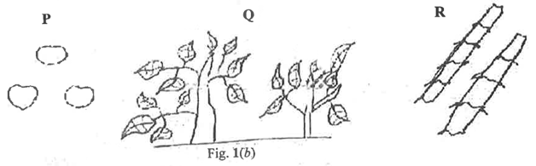
(i)

Describe briefly how each of the parts labelled P, Q and R are planted on seedbed.
(ii)

State four conditions under which R can be cultivated to produce high yield.
(c)

Fig. 1(c) is an electric circuit diagram
Study it carefully and answer the questions that follow
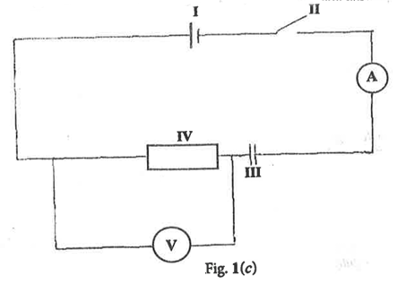
(i)

State one function for each of the parts labelled I, II, III and IV.
(ii)

If the voltmeter reads 2.4 V and the ammeter reads 0.8 A when the circuit is closed, calculate the value of the part labelled IV.
(iii)

State one way of conserving the value of the part labelled I in the circuit.
(iv)

State two observations that can be made when the circuit is closed.
(d)

Fig. 1(d) illustrates an experiment performed to separate the components of a mixture.
Study it carefully and answer the questions that follow
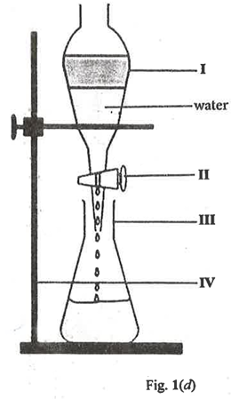
(i)

Describe briefly the process of this experiment.
(ii)

State one function for each of the parts labelled II and IV.
(iii)

State two precautions that should be taken to obtain reliable results when performing this experiment.

SECTION B
Answer three questions only from this section
2.
(a)

(i)

Given a flashlight, a tennis ball and a screen, draw a diagram to show how a shadow can be formed.
(ii)

A student seeking to determine the volume of an irregular body of mass 4 kg used a graduated cylinder in an experiment.
Fig. 2 illustrates two key stages of the experiment where A indicates a setup before the irregular body was immersed and B indicates the same setup after the irregular body was immersed.
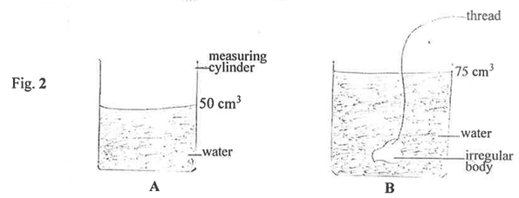
Determine the density of the irregular body.
(iii)

State two precautions that must be taken to obtain reliable results.
(b)

State three safety precautions to prevent accidents during the use of liquefied petroleum gas in the home.
(c)

Explain briefly the scientific princible underlying each of the following waste management practices:
(i)

Composting;
(ii)

Recycling;
(iii)

Incineration.
(d)

The digestive system of two domestic animals were provided. One is that of a goat and the other is that of a rabbit.
Outline three features that would help to differentiate between the two digestive systems.

3.
(a)

You have been given maize, cowpea, cassava and cabbage to cultivate on a piece of land using crop rotation system.
(i)

Design a 4-year rotational program using the given crops.
(ii)

Give two reasons for the sequence given in (a)(i).
(b)

A student is suspected of having contracted COVID-19.
(i)

Give three symptoms that the student may exhibit to confirm this suspicion.
(ii)

Suggest two ways to prevent the spread of COVID-19 in the school.
(iii)

Give two reasons why COVID-19 was declared as a pandemic.
(c)

The mass of a vehicle is 1000 kg and travels at 100 m s⁻¹. If the vehicle accelerates to 150 ms⁻¹ in 10 s, calculate the:
(i)

acceleration of the vehicle;
(ii)

force that acts on the vehicle;
(iii)

final momentum when the vehicle comes to a stop.

4.
(a)

A student who went to bed immediately after eating complained of stomach upset the next morning. A doctor prescribed a liver salt, whose major composition is NaHCO₃ as the medication.
Using a balanced chemical equation, explain how the liver salt would relieve the student from this discomfort.
(b)

Fig. 4 is an illustration of a body of mass 20 kg placed on top of a wall of height 10 m.
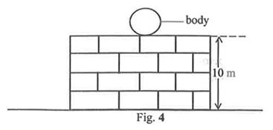
Calculate the energy of the body.
(c)

(i)

Define the term light emitting diode (LED).
(ii)

Mention two devices that use LED in their operation.
(d)

A student was tasked to prepare a raised nursery bed for nursing tomato seeds:
(i)

Suggest two simple tools that could be used in the nursery bed preparation;
(ii)

State one function each of the tools listed in (d(i).
(e)

(i)

State three observable features of an animal cell.
(ii)

State two functions of a nerve cell.

(a)

Fig. 5 is an electrical circuit diagram.
Study it and answer the questions that follow.
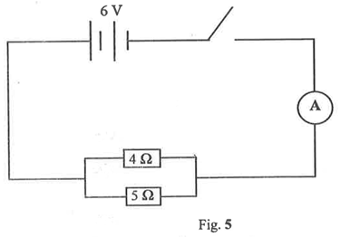
Calculate the:
(i)

effective resistance in the circuit when it is closed;
(ii)

current that will flow through the circuit when it is closed.
(b)

(i)

Differentiate between an organic fertilizer and an inorganic fertilizer.
(ii)

Outline briefly the steps involved in preparing raised beds.
(c)

(i)

State one function each of the following components of blod:
(α)

red blood cells;
(β)

white blood cells;
(γ)

blood plasma.
(ii)

Explain briefly the impact of each of the following organisms on humans:
(α)

housefly;
(β)

grasshopper.
(d)

Describe briefly the formation of an ammonia molecule after an interaction between ₁H and ₇N atoms.

